**LAB 9**

**IMPLEMENTATION OF LINKED SERVER WITH ORACLE**

**OBJECTIVE**

To implement linked server using Oracle

**EXERCISE**

**Implement Linked Server using Oracle**

**STEPS**

**1-) Creating a Linked Server to an Oracle System**

* Go to Sql Server Management Studio🡪 Object Explorer 🡪 Server Objects 🡪 Linked Server 🡪 Providers 🡪OraOLEDB.Oracle.
* **NOTE:** If this provider is present then continue your work. But this must be checked before proceeding otherwise linked server will not get configured.

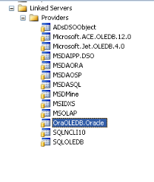

* Right Click on OraOLEDB.Oracle🡪 Properties 🡪 Check ‘Allow in Process’ 🡪Press OK.

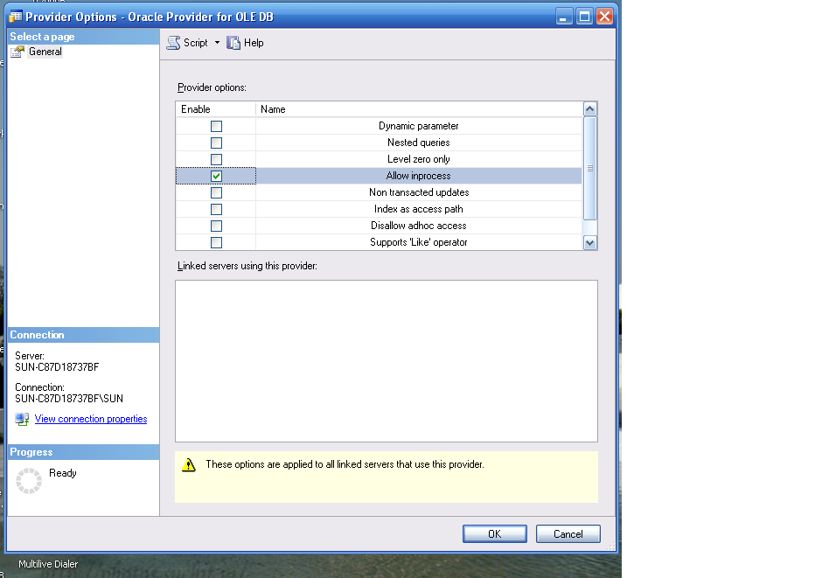

* Fill Net Service Name(any name)🡪 Press Next

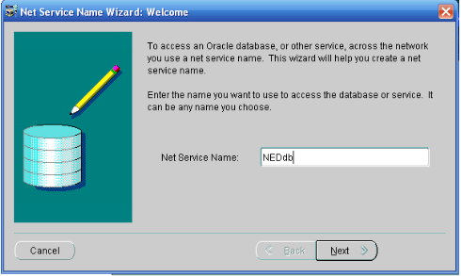

* Select TCP/IP (Internet protocol)🡪 Press Next

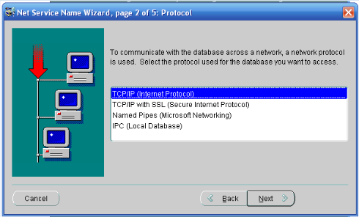

* Enter Host Name (your PC Name) and port number 1521 🡪 Press OK

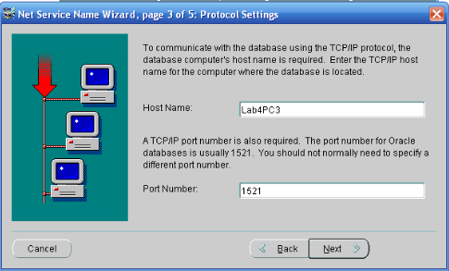

* Enter Service Name ‘orcl’ (this name is present TNSNAMES.ORA file which is located in oracle’s folder) 🡪 Press Next

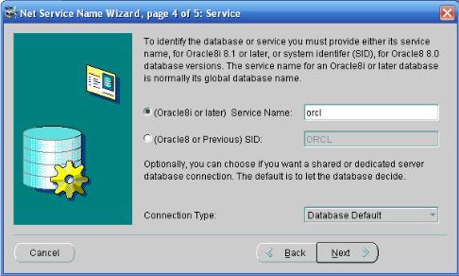

* Test the Connection🡪 ‘Connection Successful’ message will appear on the screen 🡪 Close the window

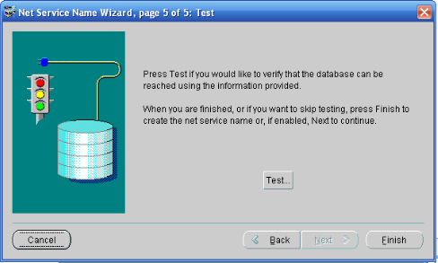

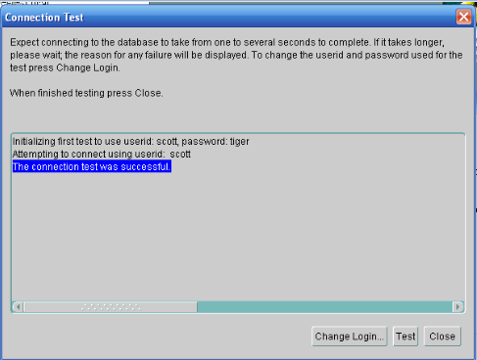

* Enter service name, host name and port number 🡪Menu bar 🡪 Click File 🡪Save Network Configuration

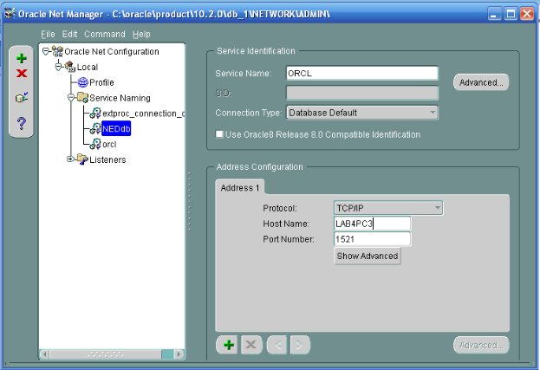

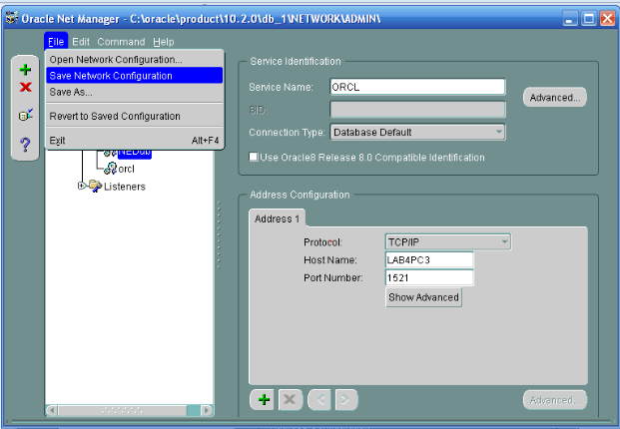

**2-) Creating a Linked Server to an Oracle System using SQL Server Management Studio**

* Go to SSMS 🡪 Object Explorer 🡪 Server Objects 🡪 Right Click Linked Server 🡪 New Linked Server

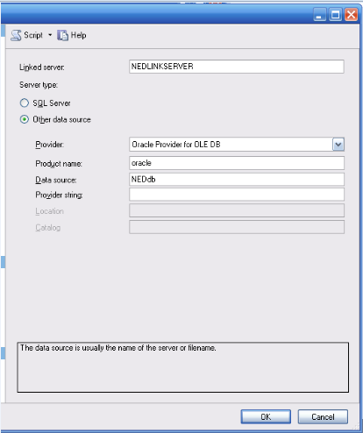

* Enter Linked Server Name (any name), Select Oracle provider for OLEDB, enter product name and data source 🡪 Press OK 🡪 Select Be made using Security Context 🡪 enter username and password.

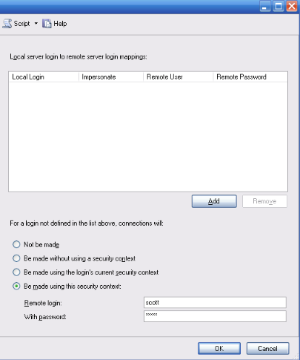

**3-) Creating a Linked Server via T-SQL**

A linked server can also be created via T-SQL using the sp_addlinkedserver stored procedure. When a distributed query is executed that accesses a table on the linked server, the local server must log on to the linked server on behalf of the user to access that table. The sp_addlinkedsrvlogin stored procedure creates a mapping between a login on the local instance of SQL Server and a security account on a remote server.

Executing sp_addlinkedserver automatically creates a default mapping between all logins on the local server and remote logins on the linked server. The default mapping states that SQL Server uses the user credentials of the local login when connecting to the linked server on behalf of the login. This is equivalent to executing sp_addlinkedsrvlogin with @useself set to true for the linked server, without specifying a local user name.

**4-) Using OPENQUERY**

The following is an example of using the T-SQL OPENQUERY construct to perform a distributed query against the linked server. This query retrieves records from the table called prod_table that resides on the remote server to which the linked server called PRODMASTER is mapped.

select * from openquery(PRODMASTER, 'select * from prod_table')